Configurations OSPF Phase 6
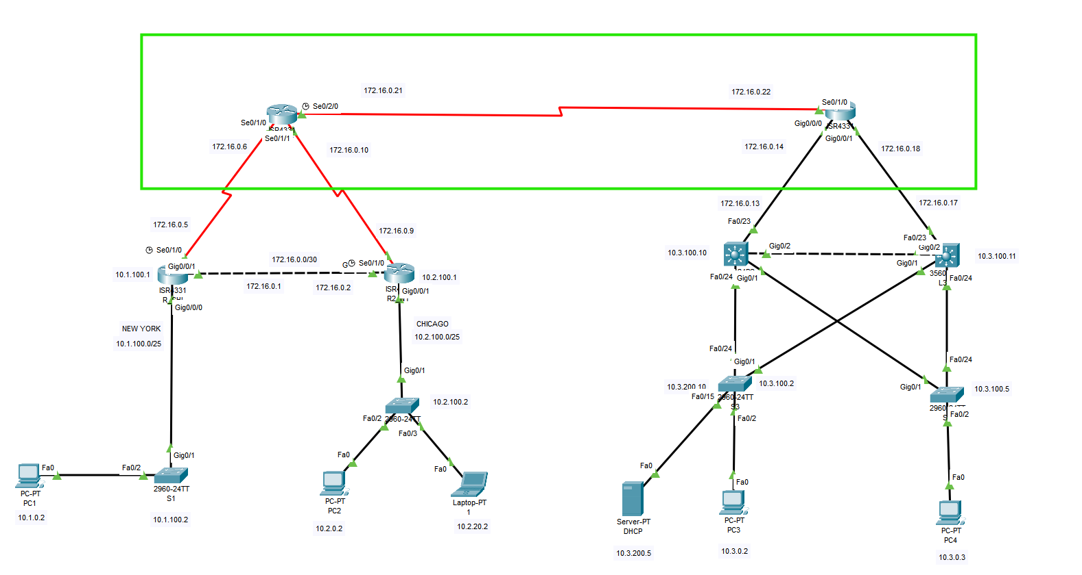
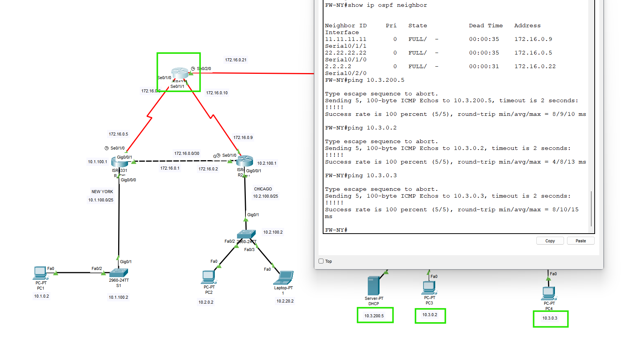
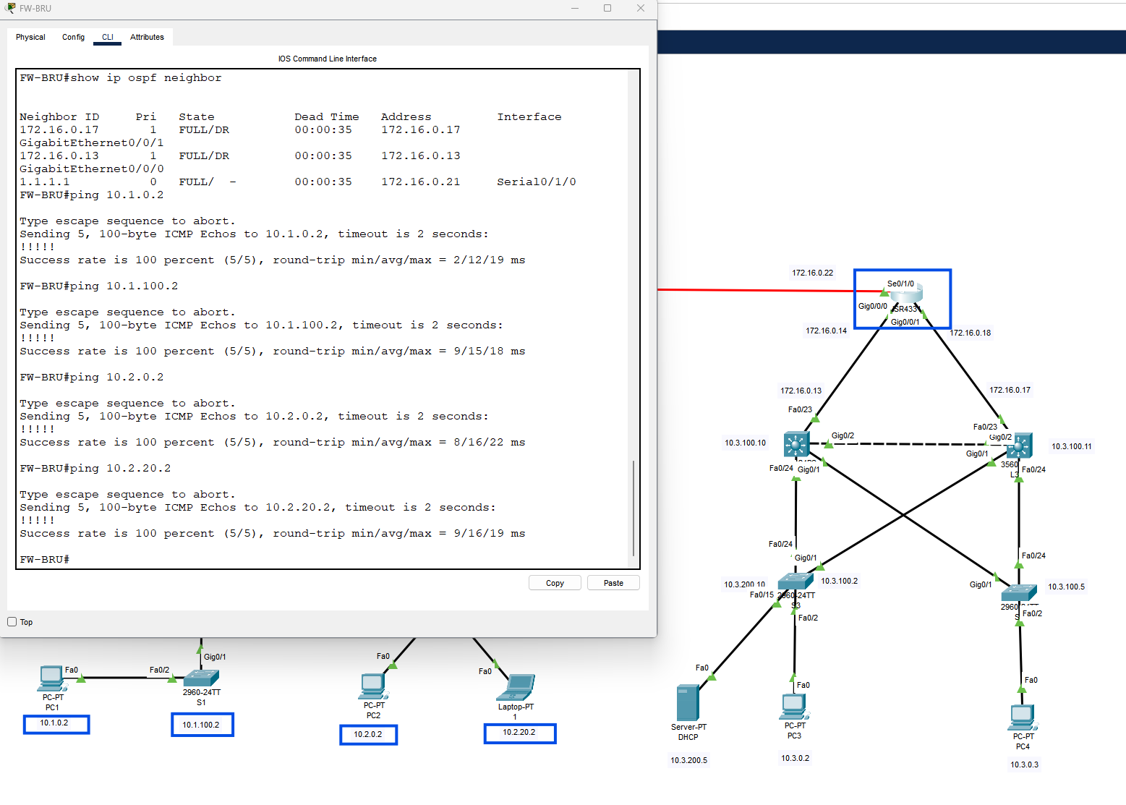
FW-NY#show running-config
Building configuration...
Current configuration : 1310 bytes
!
version 15.4
no service timestamps log datetime msec
no service timestamps debug datetime msec
no service password-encryption
!
hostname FW-NY
!
!
!
!
!
!
!
!
ip cef
no ipv6 cef
!
!
!
!
!
!
!
!
!
!
no ip domain-lookup
!
!
spanning-tree mode pvst
!
!
!
!
!
!
interface GigabitEthernet0/0/0
no ip address
duplex auto
speed auto
shutdown
!
interface GigabitEthernet0/0/1
no ip address
duplex auto
speed auto
shutdown
!
interface GigabitEthernet0/0/2
no ip address
duplex auto
speed auto
shutdown
!
interface Serial0/1/0
ip address 172.16.0.6 255.255.255.252
!
interface Serial0/1/1
ip address 172.16.0.10 255.255.255.252
!
interface Serial0/2/0
description *** WAN to FW-BRU ***
ip address 172.16.0.21 255.255.255.252
clock rate 2000000
!
interface Serial0/2/1
no ip address
clock rate 2000000
shutdown
!
interface Vlan1
no ip address
shutdown
!
router ospf 10
router-id 1.1.1.1
log-adjacency-changes
passive-interface default
no passive-interface Serial0/1/0
no passive-interface Serial0/1/1
no passive-interface Serial0/2/0
network 172.16.0.20 0.0.0.3 area 0
network 172.16.0.4 0.0.0.3 area 0
network 172.16.0.8 0.0.0.3 area 0
!
ip classless
ip route 0.0.0.0 0.0.0.0 172.16.0.22
!
ip flow-export version 9
!
!
!
!
!
!
!
line con 0
!
line aux 0
!
line vty 0 4
login
!
!
!
end
FW-NY#
FW-BRU#show running-config
Building configuration...
Current configuration : 1173 bytes
!
version 15.4
no service timestamps log datetime msec
no service timestamps debug datetime msec
no service password-encryption
!
hostname FW-BRU
!
!
!
!
!
!
!
!
ip cef
no ipv6 cef
!
!
!
!
!
!
!
!
!
!
no ip domain-lookup
!
!
spanning-tree mode pvst
!
!
!
!
!
!
interface GigabitEthernet0/0/0
ip address 172.16.0.14 255.255.255.252
duplex full
speed 100
!
interface GigabitEthernet0/0/1
ip address 172.16.0.18 255.255.255.252
duplex full
speed 100
!
interface GigabitEthernet0/0/2
no ip address
duplex auto
speed auto
shutdown
!
interface Serial0/1/0
description *** WAN to FW-NY ***
ip address 172.16.0.22 255.255.255.252
!
interface Serial0/1/1
no ip address
clock rate 2000000
shutdown
!
interface Vlan1
no ip address
shutdown
!
router ospf 10
router-id 2.2.2.2
log-adjacency-changes
passive-interface default
no passive-interface GigabitEthernet0/0/0
no passive-interface GigabitEthernet0/0/1
no passive-interface Serial0/1/0
network 172.16.0.20 0.0.0.3 area 0
network 172.16.0.12 0.0.0.3 area 0
network 172.16.0.16 0.0.0.3 area 0
!
ip classless
!
ip flow-export version 9
!
!
!
!
!
!
!
line con 0
!
line aux 0
!
line vty 0 4
login
!
!
!
end
FW-BRU#

